

Kingdom of Saudi Arabia

Ministry of Higher Education

Hail University

College of Computer Science and Engineering

Department Name

المملكة العربية السعودية

وزارة التعليم العالي

جامعة حائل

هندسة علوم وهندسة الحاسب الآلي

Please write the department here

**violence detection**

*<project logo>*

**Students**

|  |  |
| --- | --- |
| Raghad alkhyari | 202002115 |
| Taif alrashidi | 202001322 |
| Sadeem alamir  Fatmah alshammry  Rida alshammari  May mohammed | 33333333  202001700  202006208  201806338 |

*Committee members:*

Dr. Name *Affiliation Supervisor*

Dr. Name *Affiliation* *Examinator*

Dr. Name *Affiliation Examinator*

Dr. Name *Affiliation Examinator*

*Submitted to the Computer Science Department as fulfilment of the requirements for the Bachelor degree from Hail University*

*Hail-Saudi Arabia*

*1444/1445 (2023/2024)*

**Acknowledgement**

We would like to thank Dr. Arwa Aledaily for the efforts that she provided for our team and for her guidance

*Raghad alkhyari*

*Taif alrshedi*

*May mohammad*

*Rida alshammry*

*Fatimah alshammary*

*Sadeem alamir.*

**Dedication**

This project is dedicated to all the worried parents out their who care about their kids safety

*Raghad alkhyari*

*Taif alrshedi*

*May mohammad*

*Rida alshammry*

*Fatimah alshammary*

*Sadeem alamir*

**Certificate**

I certify that this project report has been prepared and written under my direct supervision and guidance. The project report is approved for submission for discussion and evaluation.

*Dr. Arwa aledaily*

*Date November 30, 2024*

*Signature*

Abstract

This **project** presents a deep learning-based approach for violence detection in video sequences, leveraging a Conv3D and LSTM hybrid architecture. The model preprocesses input videos by extracting and resizing frames, which are then passed through a pipeline combining 3D convolutional layers and temporal analysis using LSTM. A small custom dataset of violence and non-violence videos was utilized for training, achieving promising results despite limited data size. The implementation includes a Flask-based web application, allowing real-time video classification through user uploads. Future work aims to enhance the dataset's size and diversity to improve model robustness and generalization.

Keywords: deep learning, CONV3D, LSTM, Flask**,RNNs,CNNs**

الملخص

يقدم هذا المشروع نهجًا قائمًا على **التعلم العميق** لاكتشاف العنف في **رسوم الأطفال**. يقوم النموذج بمعالجة مقاطع الفيديو المدخلة مسبقًا عن طريق استخراج الإطارات وتغيير حجمها، والتي يتم تمريرها بعد ذل**ك الى خوازميات التعلم العميق (الذاكره طويله وقصيره المدى ، الشبكات العصبيه). حيث يتم استخدام مجموعه من المقاطع الصغيره مستخرجه من رسوم الأطفال للتدريب عليها ومعالجتها لإخراج نتيجه من صنفين (عنف ، ليس عنف) وربط نموذج الذكاء الاصطناعي الى واجهه موقع تسمع للمستخدم بتحميل مقاطع وتحديد اذ هذه المقاطع تحتوي على مشاهد عنف ام لا**

**الكلمات المفاتيح:** التعلم العميق, **الذاكره طويله وقصيره المدى ، الشبكات العصبيه**.

**Table of Contents**

Acknowledgment---------------------------------------------------------- I

Dedication II

Certificate III

Abstract ------------- IV

Abstract (Arabic) ------------- V

Table of Contents VI

List of Figures VII

List of Tables VIII

List of Abbreviations IX

Chapter One

Introduction

1.1 Introduction 1

This project seeks to create an idea that is a website that uses artificial intelligence to analyze and classify visual content using Microsoft Azure, such as images and videos, but Azure does not support videos, so we thought of building a video classification model using Python to add videos and link them to the website in order to determine the presence of violent or non-violent scenes. It is used by adding the image or video from the website, then the content is classified, and an output is shown. If the content contains violence, a percentage will be output containing the percentage of violence and the percentage of non-violence. If the content does not contain violence, a percentage will be output containing the percentage of non-violence and violence. There is also an option to return to the main page to retest other content. The idea comes from the need for digital solutions that enhance the security of digital content due to the widespread spread of inappropriate content on the Internet. It also aims to be an effective tool that helps individuals monitor content and ensure its safety quickly and accurately, especially parents, to protect visual content for their children. The benefits of the project include reducing exposure to violent content, protecting sensitive age groups such as children, and contributing to creating a safer digital environment. The system also provides an opportunity for educational institutions and social media platforms to apply higher security standards to published content. The target group includes Internet users in general, digital content providers, and supervisors of educational and entertainment platforms who are keen to provide a safe environment for users.

1.2 Problem Specification and Motivation 1

The problem with the increasing spread of cartoon videos on the Internet, it has become difficult for parents to ensure that these clips do not contain violent scenes or content that is not suitable for children. Although many of these clips may seem harmless and directed at children, they may contain scenes that may have a negative impact on children's behavior and psychology. With the increasing number of videos and photos published, it has become impossible for parents to monitor each video manually. The problem is further exacerbated because many video and photo platforms do not provide effective tools to classify content based on whether it contains scenes of violence or not. Therefore, there is a dire need for technical solutions based on artificial intelligence to classify these clips quickly and accurately so that parents and educational institutions can ensure the safety of the content that children are exposed to and reduce the effort in reviewing it. The motivation the motivation for the project is to use artificial intelligence to improve a site that classifies cartoon clips quickly and accurately. Due to the increase in content on the Internet, it is difficult for parents to follow up and manually check all content to ensure the safety of children. This program will help parents verify that their children's scenes are free of violence or any inappropriate content. This will symbolize reducing the negative effects of inappropriate content on children and will contribute to ensuring their safety while surfing the Internet.

1.3 Goals and Objectives 1

The main goal and purpose of the project is to create an AI-based system to classify cartoon videos and ensure that there are no violent scenes or content that is not suitable for children. The site was built to help parents and teachers quickly and accurately check the content of the videos their children are watching. The project also aims to provide a simple tool on the site that allows users to analyze videos and get an accurate percentage of violent and non-violent content in general. The goals and purpose are to create a safe digital environment for children and protect educational institutions from publishing inappropriate content

1.4 Study Scope 1

1. Classification and analysis of images and videos:

The project aims to classify and analyze images and cartoons to ensure that they are free of scenes of violence or any content inappropriate for children.

2. Use of artificial intelligence:

Artificial intelligence technologies will be activated to accurately analyze images and videos, allowing the system to quickly detect any violence or inappropriate elements.

3. Easy-to-use website: The site provides parents and teachers with the ability to easily upload images and videos, to analyze them and ensure their safety for children.

4. Focus on cartoon content: The project focuses only on the content of cartoon images

and videos and does not include live films or real objects such as people.

5. Child protection: The project seeks to protect children from harmful content, as the system focuses on accurately detecting scenes of violence in images and videos to ensure the safety of the content provided.

6. Exclusion from the scope of the study the work focuses only on excluding non-cartoon images and videos, such as realistic content and audio, and the project will not include other elements such as games, texts or audio. The scope here is specifically concerned with the content of cartoon images and videos to ensure that the objectives are clearly implemented.

1.5 Study Plan and Schedule 1

1.5 STUDY PLAN AND SCHEDULE

- STUDY PLAN

figure1



1.5-SCHEDULE

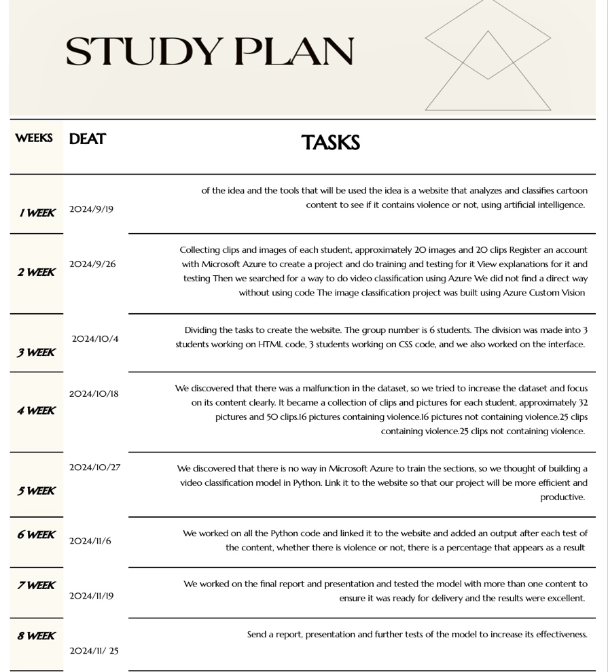

figure2

1.6 Organizing of the Chapters

Chapter 1: Introduction

In this chapter, I introduce the project and explain why it’s important. The project addresses the growing problem of violent content spreading online and how it negatively affects users, especially younger ones. The goal is to create a website that uses artificial intelligence to analyze images and videos to detect violent content. This system aims to help reduce exposure to such harmful material and make the online space safer for everyone.

Chapter 2: Literature Review

This chapter covers the background research I did to better understand the topic. I explored previous studies and projects that focused on detecting violent content using AI technologies. I also learned about key techniques, such as Convolutional Neural Networks (CNN), which are widely used in image and video analysis. This research provided the foundation I needed to build my project.

Chapter 3: Requirements Analysis

Here, I outline the main requirements needed to complete the project:

- Functional requirements: The system should be able to analyze uploaded images and videos and give accurate results.

- Technical requirements: Tools like Python, Django, and TensorFlow will be used for development.

- Constraints: Limitations include the size of the dataset and available resources for training the AI model.

Chapter 4: System Design

In this chapter, I explain how the system is designed:

- The AI model: I trained a model using labeled datasets to detect whether content is violent or not.

- Website structure: The backend was developed using Django or Flask, while the frontend uses HTML, CSS, and JavaScript for a user-friendly interface.

- Data flow: I describe how the system processes uploaded files, from the initial upload to showing the results to the user.

Chapter 5: Implementation and Results

This chapter focuses on how the project was built and the results it produced. I explain the steps I took to train the AI model, connect it to the website, and test the system. The results showed that the system worked well in most cases, although some errors occurred in specific scenarios. Overall, the project achieved its goals, but there is still room for improvement.

Chapter 6: Conclusion and Recommendations

In this final chapter, I summarize the project and its outcomes. The system successfully analyzes and identifies violent content, which can be useful in many areas. However, I recommend further improvements, such as expanding the dataset to include more diverse examples and optimizing the system for real-time applications, like live content monitoring.

Chapter Two

Introduction:

This chapter explores the main ideas and concepts related to violence detection in videos. It begins by explaining the core concepts and different types of video classification. Next, it highlights important research in the field, highlighting the challenges, past studies, and existing theories.

Finally, this chapter introduces the proposed work, including the model and hypotheses, and illustrates how this study contributes to the advancement of the field.

Background:

Concepts and Definitions:

Video classification is a technique used in computer vision to analyze and categorize videos based on their content. For this project, the two types of categories are: violence (videos that show violent content) and non-violence (videos that do not show violent content). Machine learning models, like deep learning, are commonly used for these tasks as they are able to understand patterns in video data.

Key terms in this study include:

* Frames: The images that make up a video.
* 3D Convolutional Layers: Neural network layers that analyze patterns in video frames across time.
* LSTM: A type of neural network layer that works with sequences of data, like video frames, to understand motion or time-based patterns.

Types:

There are two main types of video classification:.

1. ﻿﻿﻿Action Recognition: This method focuses on identifying specific actions within videos, such as running, jumping, or fighting.

2. ﻿﻿﻿Content-Based Classification: This method categorizes videos based on their overall content, such as classifying them as violent or non-violent.

This study classifies as content-based classification as its primary goal is to detect whether a video contains violence.

Related Work:

Issues Related to the Current Work:

One of the main challenges in detecting violence in videos is defining what exactly qualifies as "violence." This issue becomes more complicated when dealing with cartoon videos, where violence might appear exaggerated for comedic purposes. For example, a character hitting another with a frying pan in a cartoon is typically a joke, not actual violence. This is very different from scenes showing physical fights between two or more characters with visible traces of violence. Many methods focus on analyzing low-level visual features, such as color and motion, but these are often not enough for cartoons due to their unique artistic styles. Additionally, current systems face difficulties in balancing datasets and ensuring consistent accuracy across various types of videos.

Previous Studies:

Several studies have focused on violence detection in videos, primarily looking at real-life or movie scenes. These studies typically use techniques like audio-visual feature extraction and machine learning. Some notable examples include:

o ﻿﻿Giannakopoulos et al.: Combined audio and video features using the k-Nearest Neighbor method to classify violent scenes in movies.

o ﻿﻿Lin and Wang: Applied weakly-supervised learning techniques for violence detection in audio-visual content.

o ﻿﻿Vu Lam et al.: Analyzed multiple features, such as motion and visual cues, to classify violent scenes.

However, there has been less research on detecting violence in cartoons. One recent study proposed a knowledge-based system to detect violence in cartoon videos by analyzing objects and characters. While the framework successfully identified violent content, it faced challenges with character recognition due to limitations in the dataset.

Previous Theories/Frameworks/Systems:

Many existing systems combine low-level features (such as color and texture) with high-level features (such as character behavior and object context):

o ﻿﻿Bag-of-Words (BoW) Frameworks: These are commonly used, combining audiovisual features to classify scenes.

o ﻿﻿Bayesian Probability Models: These models estimate the likelihood of violence based on extracted features.

o ﻿﻿Motion Intensity Analysis: This technique measures aggression by analyzing movement patterns in video frames.

While these systems have proven effective for real-life videos, they face challenges when applied to cartoons due to their abstract nature. As a result, cartoon-specific frameworks are emerging, which focus on character and object databases to enhance accuracy.

Proposed Work:

Proposed Theory/Framework:

The proposed framework in this study focuses on detecting violence in videos by analyzing both spatial and temporal features. The framework uses deep learning techniques to process video data and classify it into two categories: violence and non-violence. The main idea is to combine 3D convolutional layers to extract visual patterns from frames and LSTM layers to analyze the sequence of frames. This combination helps the model understand both the content and motion in videos, making it suitable for detecting violence.

Proposed Model/System:

The proposed model for violence detection is based on a hybrid deep learning architecture that includes:

1. 3D Convolutional Layers: These layers are used to extract important features from video frames, such as shapes, colors, and patterns.

2. ﻿﻿﻿LSTM Layer: This layer analyzes how actions evolve over time by processing the sequence of frames.

3. ﻿﻿﻿Dense Layers with Dropout: These layers help improve the model's accuracy and reduce the chances of overfitting.

The model processes videos by extracting 10 frames per video, resizing them to 64×64, and normalizing the pixel values. These steps ensure the data is consistent and ready for the model. The dataset used contains two categories: violence and non-violence. The model is trained using binary cross-entropy loss and accuracy as the evaluation metric.

Issues Related to Proposed Work:

1. Data Imbalance: There's an imbalance between the number of violent and nonviolent videos, and there are also duplicate videos, which could affect the model's ability to learn both categories equally.

2. ﻿﻿﻿Skipped Videos: Some videos were skipped during preprocessing because they were corrupted or didn't have enough frames, which reduced the size of the training dataset.

3. ﻿﻿﻿Overfitting Risk: The model might overfit to the training data, especially with a small dataset, which could affect how well it works on new data.

4. ﻿﻿﻿Edge Cases: Some actions in videos, like intense sports or playful aggression, might confuse the model because they look similar to violent behavior.

Proposed Hypotheses:

1.Using 3D Convolutional Layers combined with LSTM will help the model detect violence more effectively by analyzing both visual patterns and motion.

﻿﻿﻿2.Preprocessing the videos to extract 10 frames will provide enough data for the model to classify the videos accurately.

﻿﻿3.Adding more balanced and diverse data to the training set will improve the model's performance and help it generalize better.

﻿﻿﻿4.Adjusting hyperparameters and using regularization techniques like dropout will reduce overfitting and make the model more reliable.

### Summary:

In this chapter, we covered the key concepts and previous research related to violence detection in videos. We started by explaining the basics of video classification, focusing on detecting violence and non-violence. We also discussed the challenges in this field, such as defining what counts as violence and dealing with complex video data.

The section on related work showed that many studies have focused on real-life videos, using methods like audio-visual features and machine learning. However, fewer studies have tackled the detection of violence in cartoons or abstract videos, which require different techniques due to their unique styles.

For the proposed work, we introduced a framework that uses deep learning to classify videos. The model combines 3D convolutional layers and LSTM layers to capture both visual and motion features. We also highlighted issues like data imbalance and overfitting and suggested hypotheses to improve the system's accuracy and reliability.

Chapter Three

Methodology Approach:

Type of Selected Method:

This study uses a quantitative research method with a focus on deep learning techniques. The approach involves training a machine learning model on labeled video data to classify videos as violent or non-violent. The chosen method is based on numerical data and uses mathematical models to evaluate performance.

Study Procedure:

The study followed a systematic procedure to ensure accurate results. It includes the following steps:

1. Data Preprocessing: Videos were processed to extract 10 frames per video, resized to 64×64, and normalized to prepare them for the model.
2. Model Development: A hybrid deep learning model was created using 3D convolutional layers to extract spatial features and LSTM layers to analyze motion.
3. Training and Evaluation: The model was trained using a dataset with two categories (violence and non-violence) and evaluated using metrics like accuracy, precision, recall, and F1-score.

Data Collection and Analysis:

3.3.2.1 Requirements -----------------------------------------------------------3

1. Hardware Requirements:

* 10GB free Storage memory
* Minimum of 8 GB RAM

1. Software Requirements:

* Python 3.9 and above
* TensorFlow Library’s
* OpenCV for video processing
* NumPy for using 3D arrays
* OS for controlling directories
* Flask to implement the code to a website interface
* HTML,CSS
* Jupiter Notebook and Visual Studio code IDE

3.3.2.2 Data Collection and Analysis--------------------------------------------------------3

* Data Collection: The dataset includes videos from two categories: violence and non-violence. These videos were collected from reliable sources to ensure quality. Some videos were skipped due to issues like corruption or missing frames.
* Data Analysis: After preprocessing, the dataset was used to train and test the model. Metrics like accuracy, confusion matrix, and classification report were calculated to measure the model's performance. The analysis showed that the model performed well but faced challenges like data imbalance and overfitting.

3.3.2.3. System Design Procedure ---------------------------------------------3

a. Use case Diagram

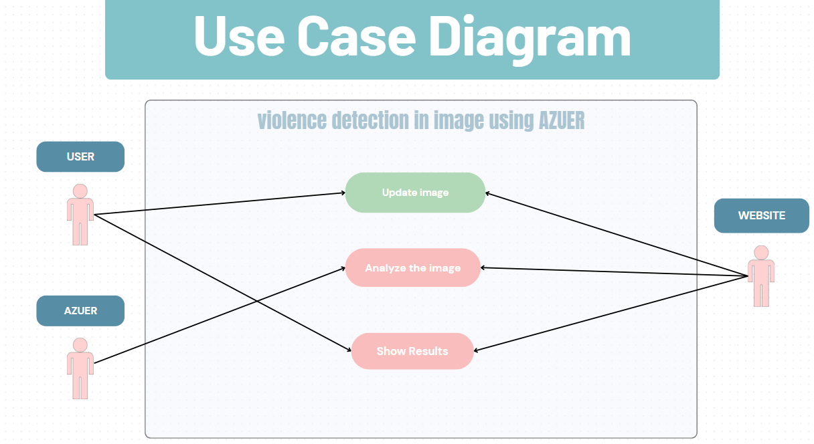

b.

figure3

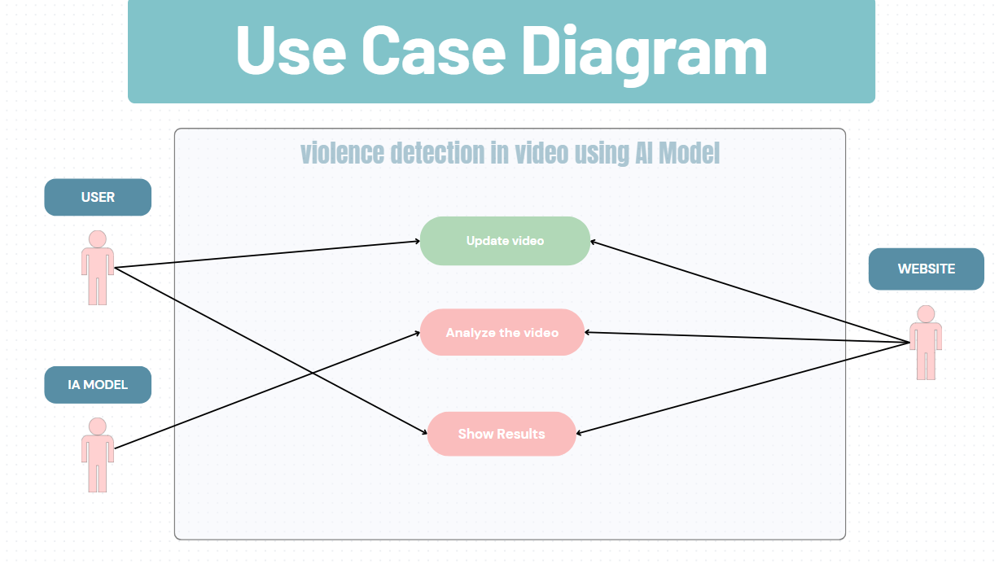

figure4

ER Diagram

c. Sequence diagram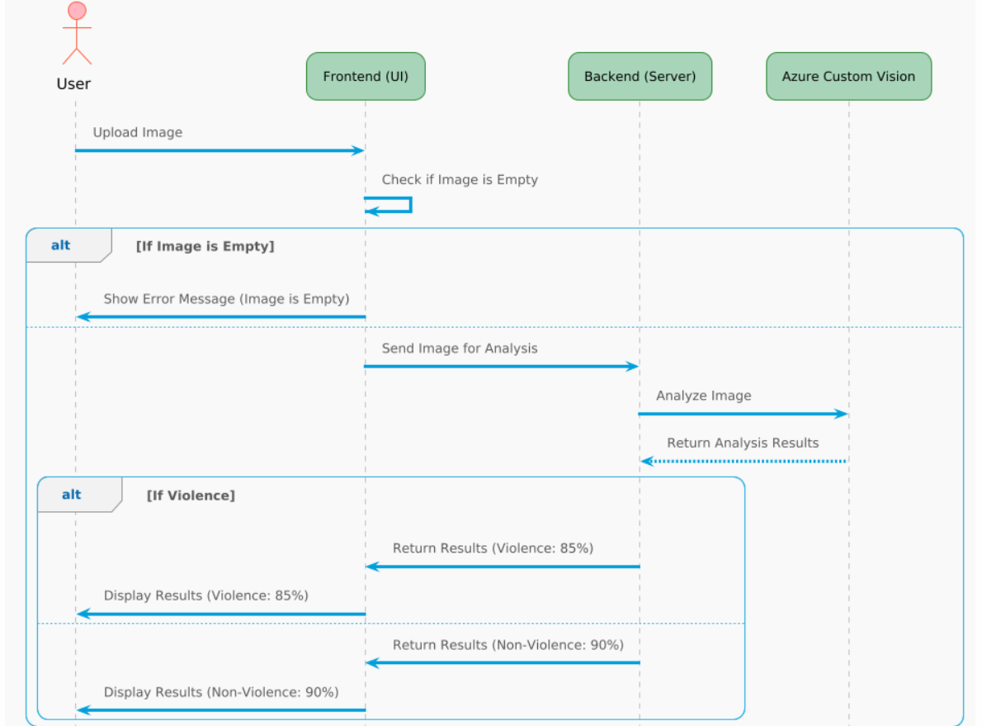

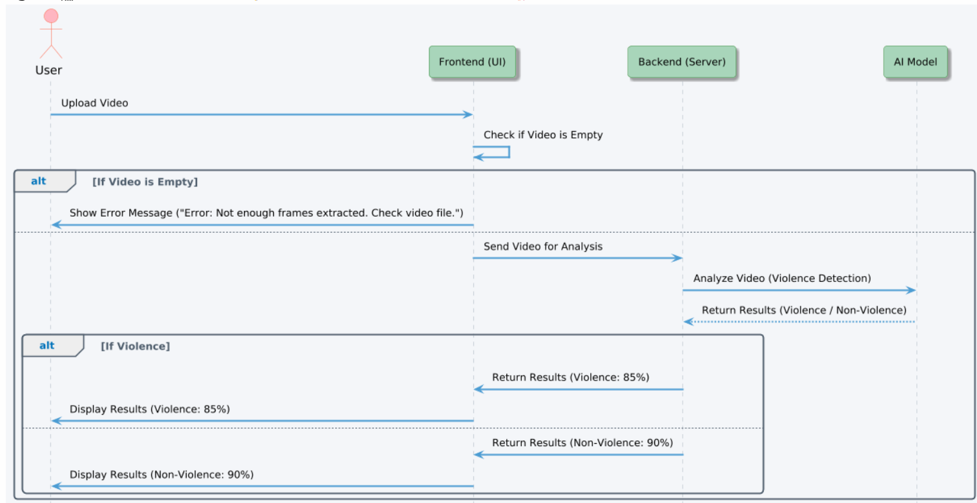figure5

figure6

Summary:

This chapter explained the methodology used to detect violence in videos. A quantitative approach was chosen, using deep learning to process and analyze the data. The study followed clear steps, including data preprocessing, model training, and evaluation. The dataset was carefully prepared, and the results were analyzed using standard performance metrics. This methodology ensured that the project was reliable and could achieve its objectives.

Chapter Four:

Implementation AND TESTING

4. 1 Introduction 4

In this chapter we will discuss the process of implementing and testing of azure custom vision and our video classification system and we also going to explain the sampling process and the testing process and what are the types of testing that we’ve used

4.2. Implementation Steps 4

1. **Data preparation:**

* ***Azure:***

to start we gathered 60 videos (30= violence, 30=non-violence) that ranges from 5 seconds to 10 seconds max for our dataset.

We extracted frames (images) from videos to implement it in azure custom vision image classification.

* ***Video classification model:***

We need to perform operation on raw data (videos) to extract 10 frames and preform operation on the extracted frames to resize the image and change the color array from BGR to RGB and store the final result in array ready to be processed

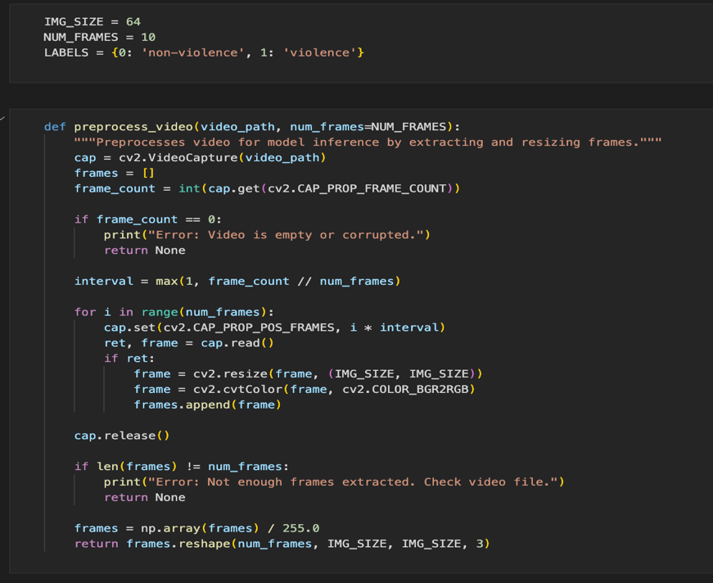

figure7

Using the function: perprocess_video() we will prepare our video data by extracting frames (10 frames) and modifying the size of the extracted images to 64x64 and also the color matrices due to the OpenCV library stores color in BGR format so we need to convert the RGB format and then store the frames into a list the converting the list to an array **the resson why we are doing this is if our image was 1000 X 1000px and we processed them al our CPUs may not handle it and there will be too many neurons that will cause overfitting** 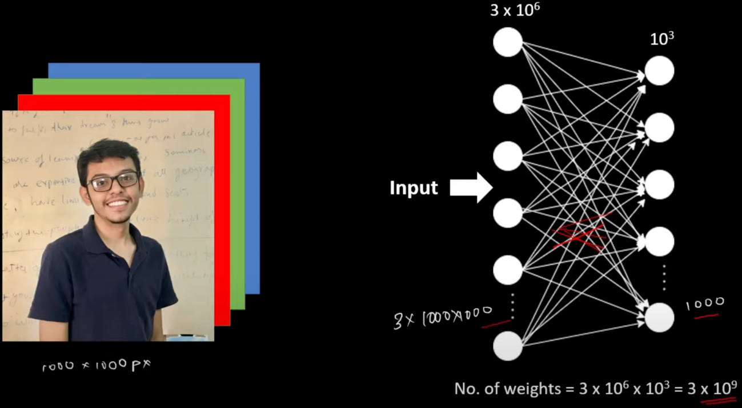

figure8

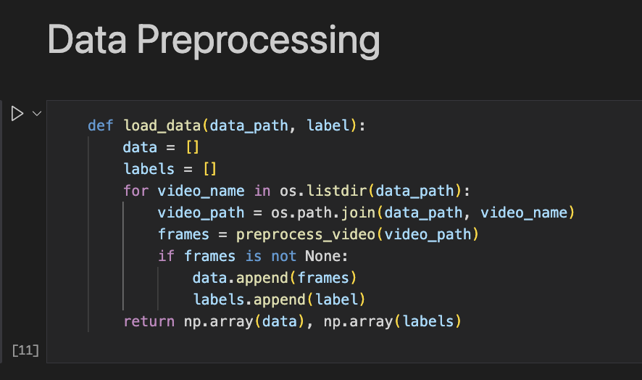

figure9

**In load_data() function we prepare our data to be trained and tested as we can see there are two lists and a for loop that iterate over all the file in a folder in our case it will iterate over all the videos in a folder e.g. violence. We will be joining every path with the video name to insure that in the training process the model reaches them. In variable frame we store the output of the preprocess_video() in it. Now we have 10 frames stored in an array and we add them to our list “data” lastly the function will return data and labels as an arrays to be used in training data**

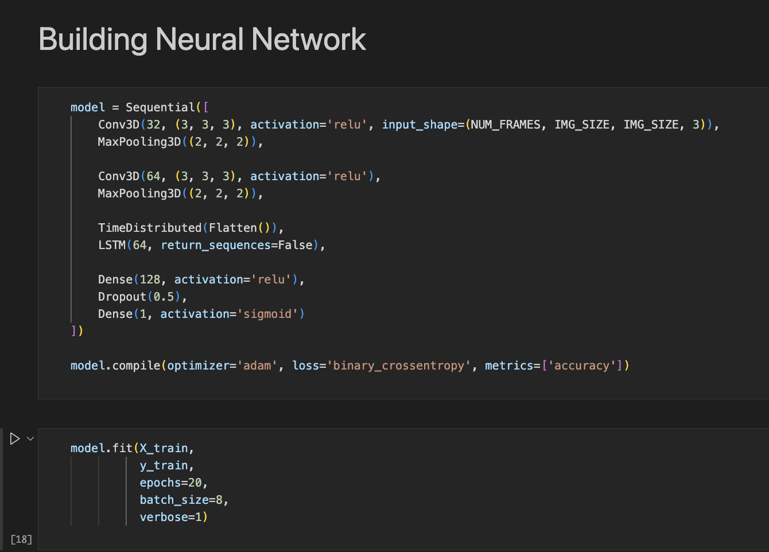



figure10

Now we are going to build our conventional neural network using CONV3D , LSTM and Dense.

* + The first line is called the input layer. In this layer:

**1st argument are the number of filter applied**

**2nd argument is the kernel size: it’s an int or specifying the size of the convolution**

**window tuple/list of 3 integers and as I highlighted in the picture since we are operating on matrices the last two numbers should be the same so we can appley the filters**

**3rd argument is** activation **Now typically applied to the output of each neuron in the network. It takes in the weighted sum of the inputs and produces an output that is then passed on to the next layer.**

**4th argument is the input_shape() and it specify the shape of the data and it only added to the input layers “first layer”**

**Looking and the two images bellow we will have a deep understanding of the process of applying filters on colorful images**

**The case with colorful images is that the size of it well be NxNx3**

**N stands for the dimension**

**3 represent the three-color channel (red, green, blue) RGB**

**Now to process this image we will need a filter that has 3 channels**

**And the outputs well be summed up in a single image of NxN**

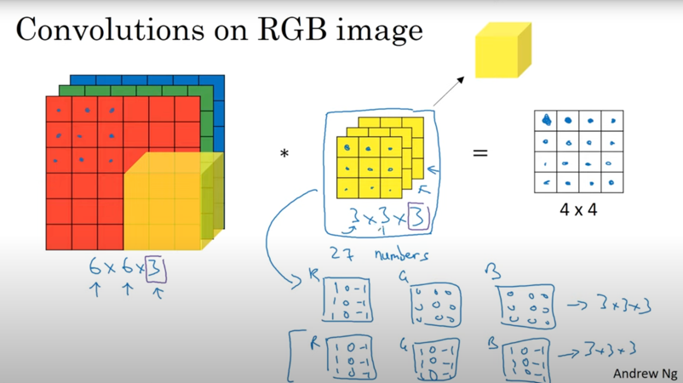

figure11

**Here is an example of how filters works:**

**By applying filters it will extract features**

**In this example two filters are applied to extract features the first feature extracted is the vertical edges and the second is the horizontal edges**

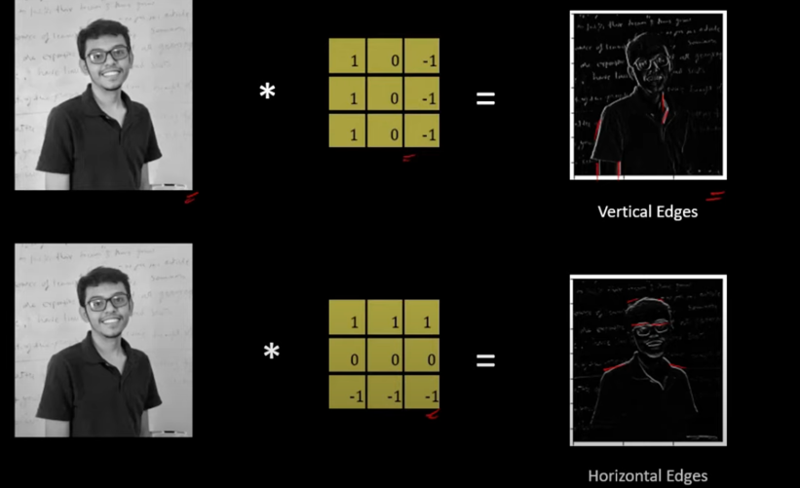

figure12

* + The 2nd layer is the maxpooling layer and it’s used to fix filters , reduce image size and enhance image it’s always used with conv layer

**The 2nd layer is the maxpooling layer**

**it’s used to fix filters , reduce image size and enhance image it’s used after the convolutional layer. Also note this layer does not train the data it only enhance it**

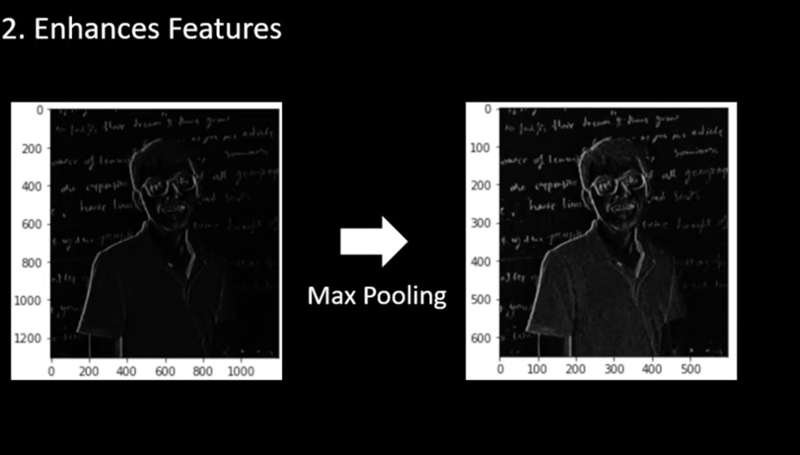

figure13

**In this image we can see the difference between the figure NUM and this figure and thanks to the maxpooling layer the image is enhanced**

* + The 5th layer is TimeDistibuted

**This layer is responsible for enabling us to process time series in our case the frames we extracted in ordered of time**

* + The 6th layer is the LSTM

LSTM stands for long short term memory and it’s a type of recurrent neural network (RRNs) it has three gates :

* Forget gate
* Input gate
* Output gate

The LSTM is used when we have an input that is an ordered sequence of information the RNN it’s a network that uses output from previous step as an input for the next step then the output is used along with the next input

**- The number 64 defines the number of inputs**

* + The 7th layer is the fully connected layer
* Dense(128): Fully connected layer with 128 neurons, applying **Relu a**ctivation.
* Dropout(0.5): Regularization technique to prevent overfitting, randomly drops 50% of the neurons during training.
* Dense(1): Final layer with 1 output neuron and **a sigmoid** activation:
  + **give** a probability score between 0 and 1 for binary classification (e.g., violence vs. non-violence) **note that sigmoid is used only for 1 ouput if we need more then 1 output we use softmax but in this case sigmoid is the best way to go**.

**The** model.compile() **Is to perpare the model for training**

* **optimizer='adam'**: Adaptive Moment Estimation, a popular optimizer for faster convergence.
* **loss='binary_crossentropy'**: Loss function used for binary classification tasks.
* **metrics=['accuracy']**: Evaluates the model’s performance using accuracy.

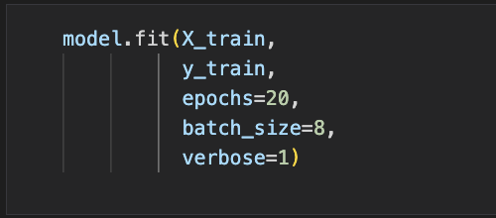

figure14

Model.fit() is for training the data

X_train is the whole videos

Y_trian is the lables for videos

Epoch=20 is the number of itration

Batch_size =8 is the number of processed data at once

Verbose = display the detailed progress for each epoch

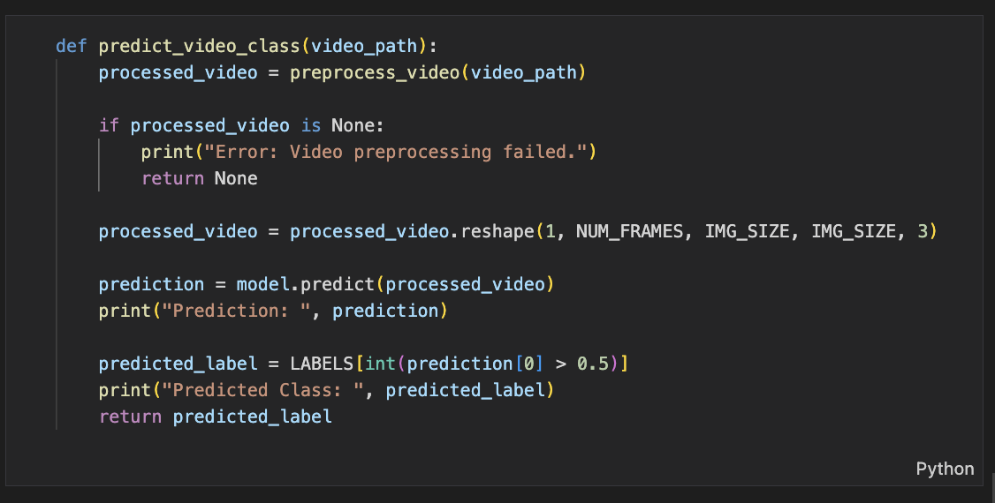

figure15

This function well predict if a video is violent onr not

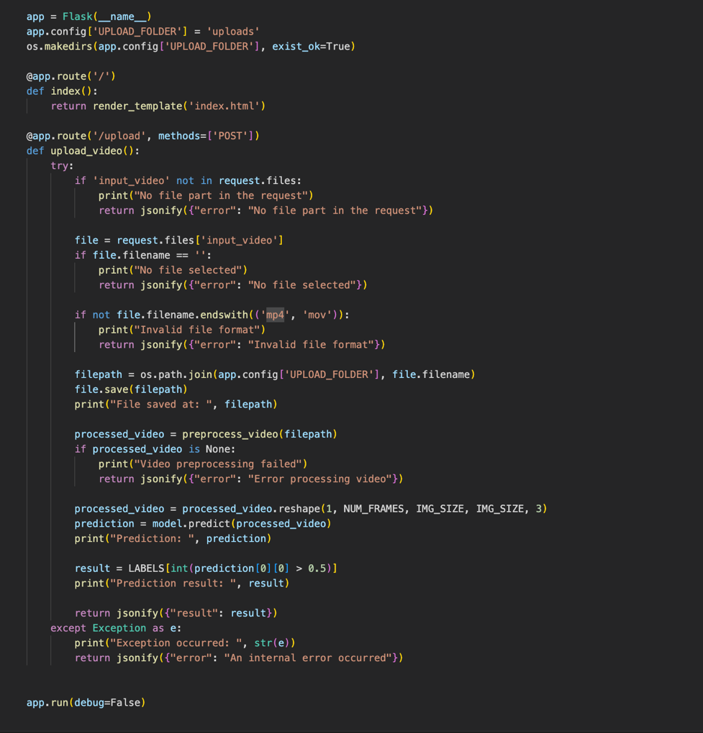

figure16

**This code connect our model to a website using flask**

* ***Azure:***
* Go to [www.portal.azure.com](http://www.portal.azure.com/)
* Creat an acount with azure by clicking on pay as you go sense we’re only going to use one service from azure AI servicess
* Create a resource group keep in mind you’re only alowed to builed two resource group for free and building more than that you will be charged for it
* go to to resource menu and search for Custom vision the click on “create” keep in mind there is a limit to your sebscription “ you can only create it once for free” and then click on “ go to custom vision portal “ and sign in using your azure account
* create new project and select what is highlighted. We want to classify if the image is violent or not that why we will select the option of single class per image. Also make sure to select the domain to general so you can deploy your model to a website

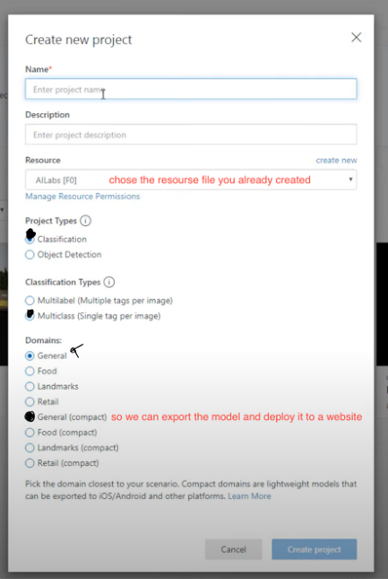

figure18

* upload images

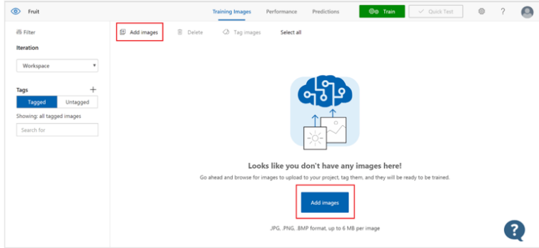 figure19

* Now write a tag that it’s suitable to the image. Note that you can upload multilabel images to a single tag in our case but

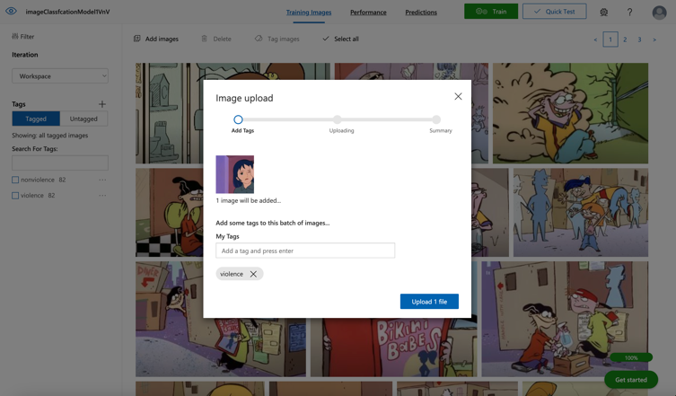 figure19

* Now that you have built your dataset you will train your model note that the longer you train your model the better the result you get. Our image dataset has reached 200 and for some reason the accuracy was between 70 and 60 we thought that there was something wrong in the data so we removed more than 40 images on phases and we kept getting the same result. Until we trained it for 24 hours we noticed a major change in the accuracy and it went from 60 to 85.

figure20

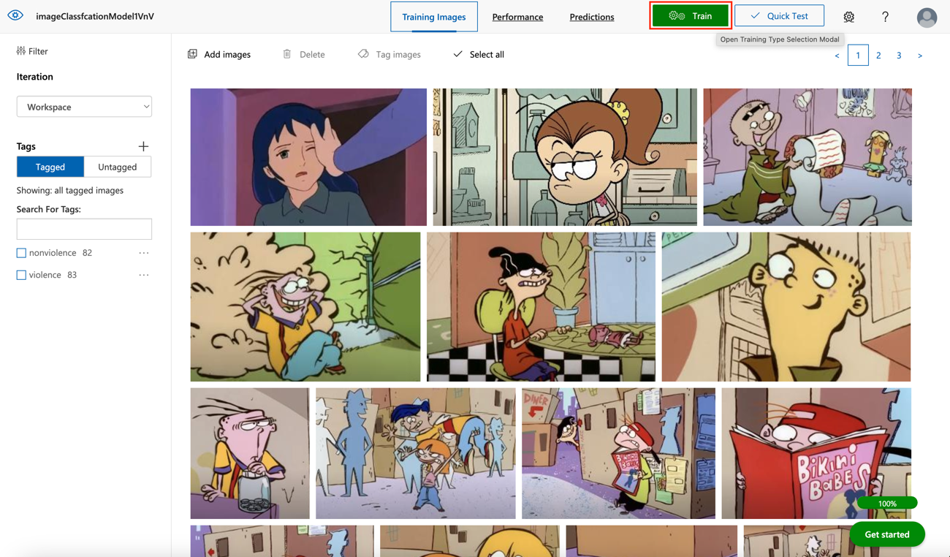

figure21



* After the training complete click on performance to see the result. You can see the difference in numbers

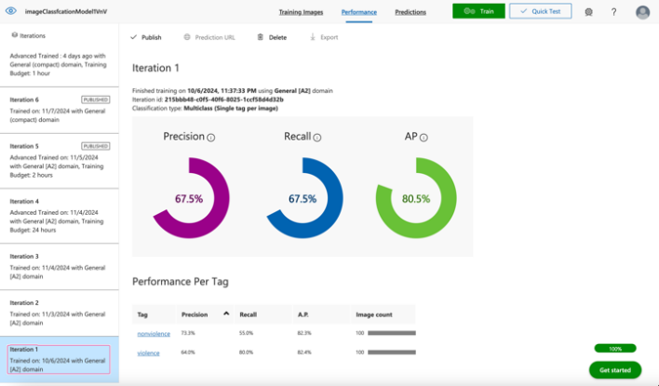

figure22

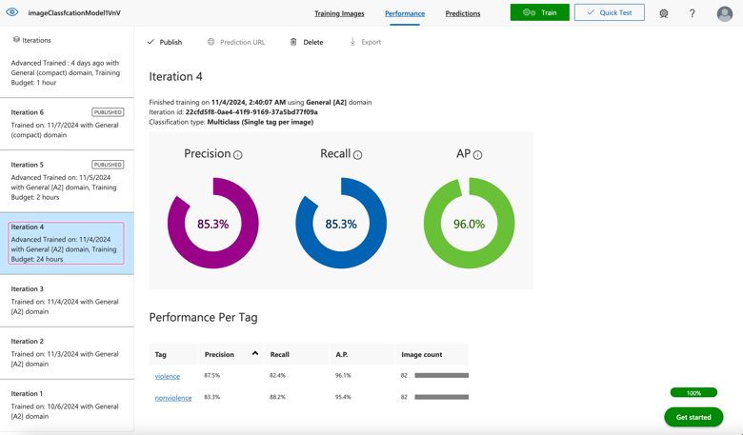

figure23

4.2.1 Implementation Procedure --------------------------------------------------------4

Azure:

Now to implement your image classification in your website we will need to use flask

1. Go to your azure custom vision model and publish your mode

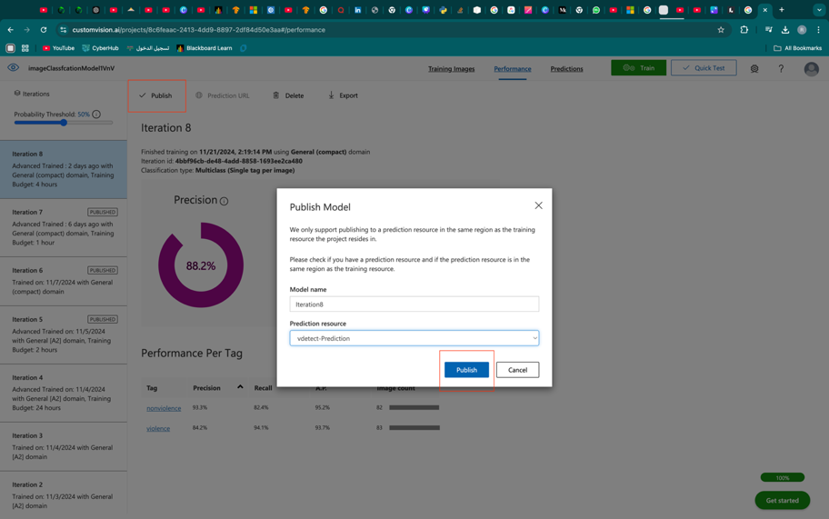

figure24

1. After you publish your model you can see publish word in the iteration model



figure25

1. Now since we’re going to upload images and testing them using our website we will choose the second option

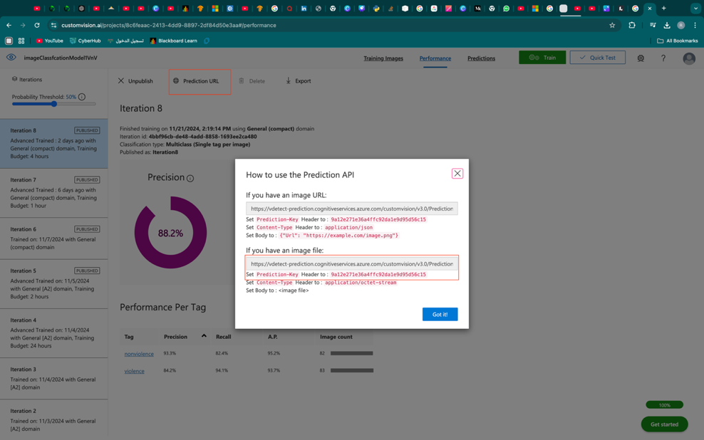

figure26

1. Copy the URL link (“end point”) and the Api key so we connect our website to azure using flask framework

FIGURE 17:

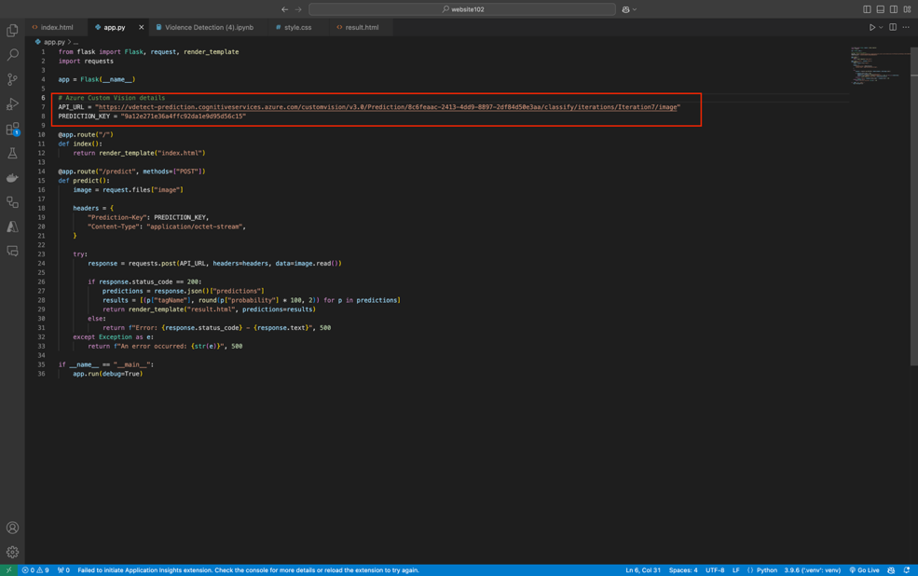

figure27

4.2.2 Sampling Procedure ---------------------------------------------------------------4

1- Dataset collection

1. we started gathering video clips (5s-10s) long to our video dataset
2. From previous videos that we’ve gathered we manually extracted frames to our images dataset on azure.
3. We created two folders ( train , test ) each folder contain another two folders (violence , non-violence)

2-Data labeling

* we split the videos into two folders ( violence , non-violence )
* for the images classification we simply uploaded the videos to azure images classification project and we labeled out data manually.

4.3 Testing Procedure ------------------------------------------------------------------------4

4.3.1 Types and Steps of Testing ------------------------------------------------------4

1. video classification test

there are two ways we can test videos

1. using our interface :

* First go to our website and you will be welcomed by our robot

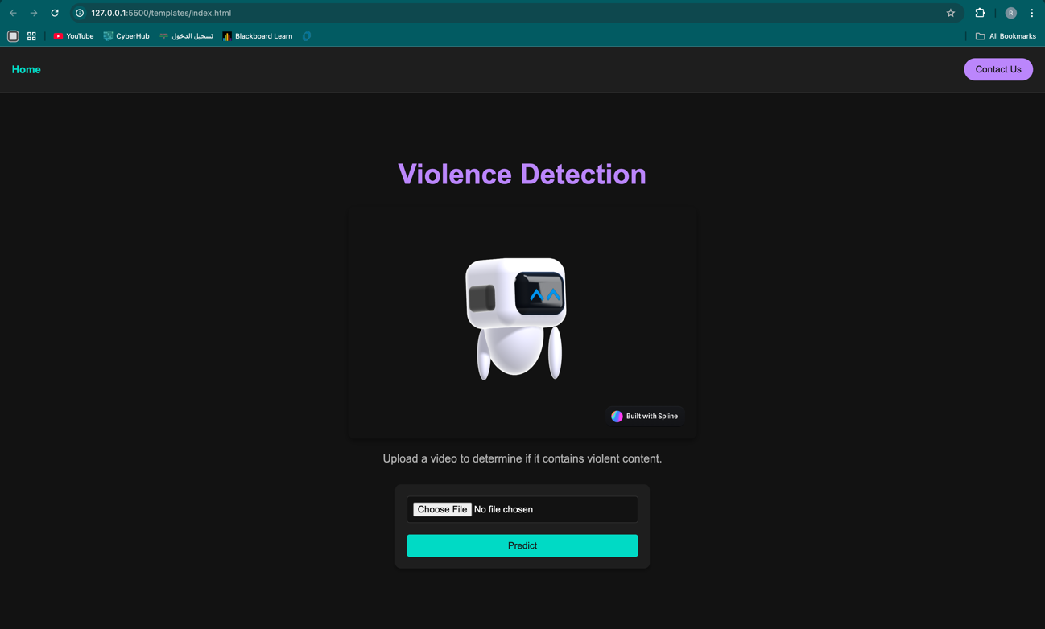

figure28

* Select a video not smaller than 5s and not larger then 10s

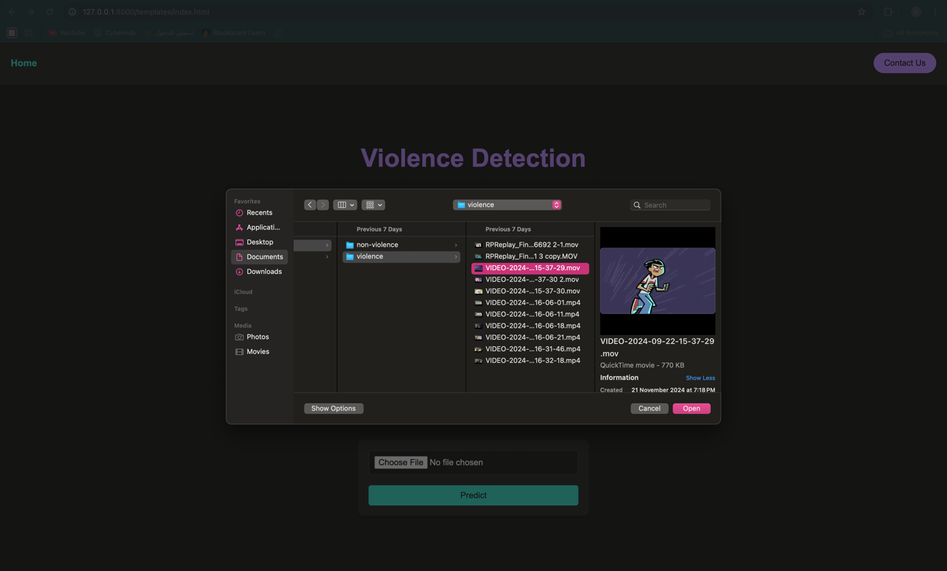

figure29

* Click on predict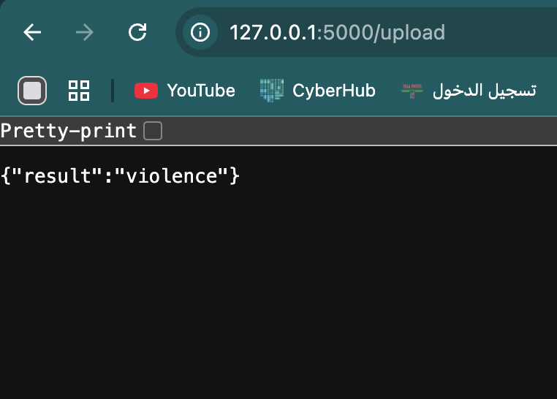
* figure30

1. directly using the code :

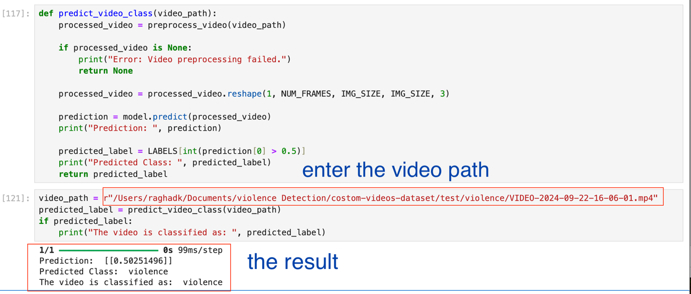

figure31

1. image classification test

* using azure custom vision portal go to your project and click on quick test



figure32

* Click on brows files in the image is on your local machine and choose an image if not u can copy a URL image and paste it in the URL box

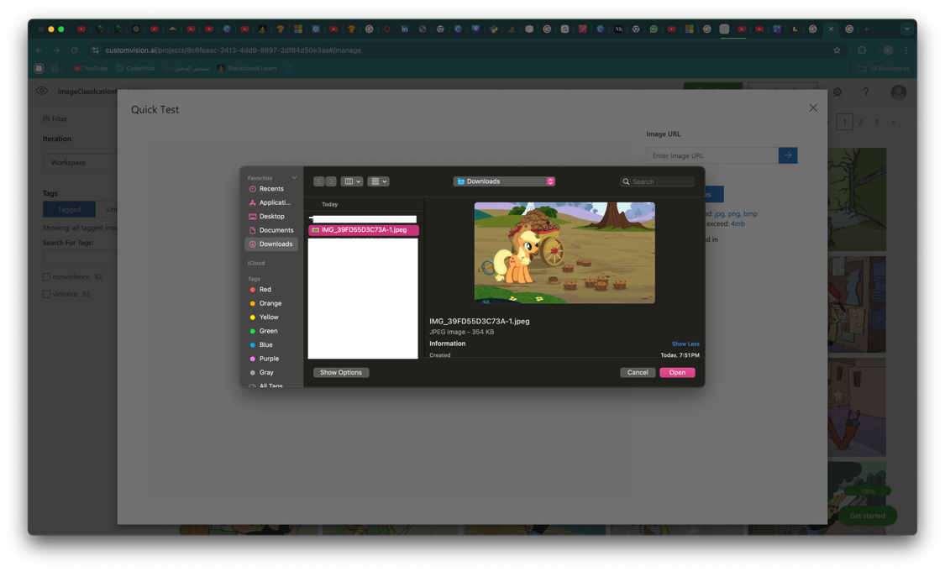

figure33

Note that This image has never been seen by our model

* Result: the model successfully classified the image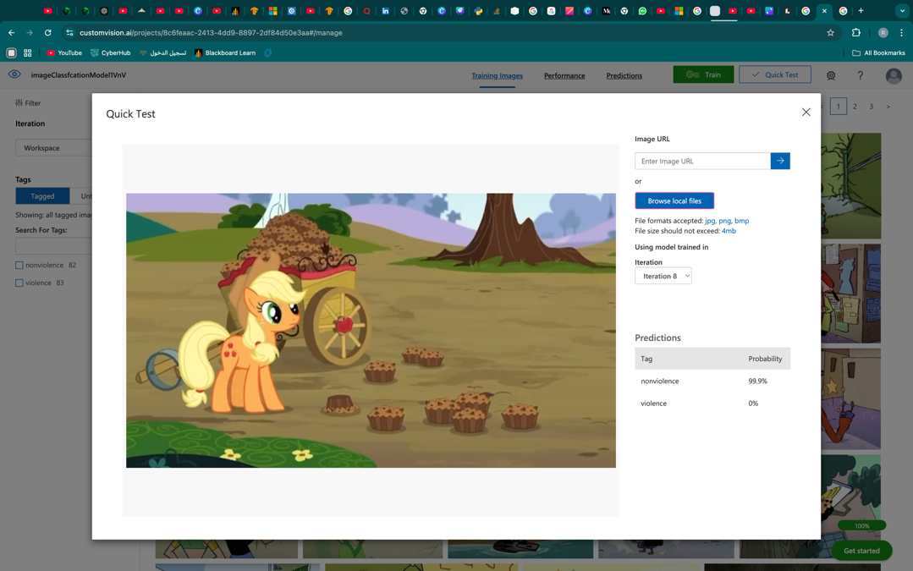

figure34

* Testing using our integrated website :
* Click on chose file and choose an image than click in analyze

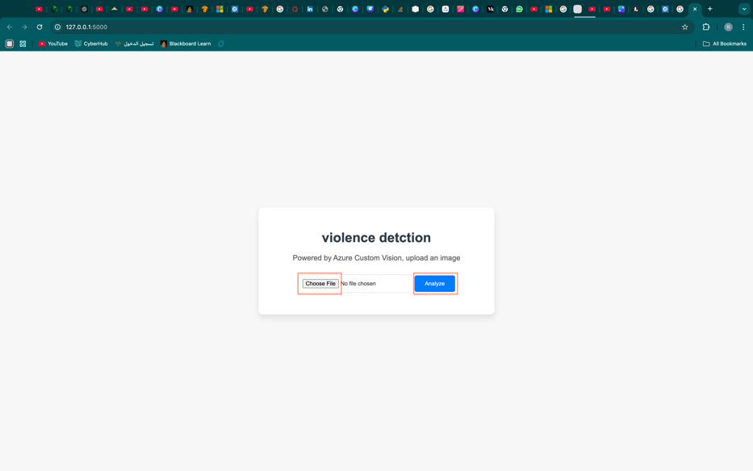

figure35

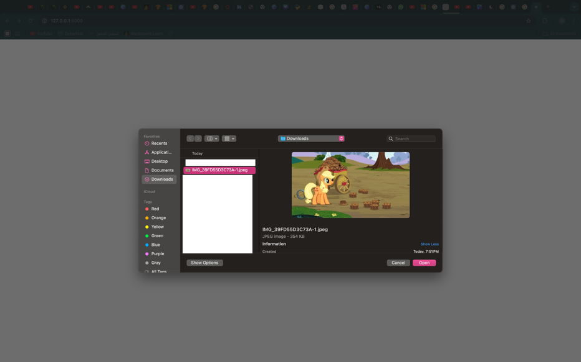

figure36

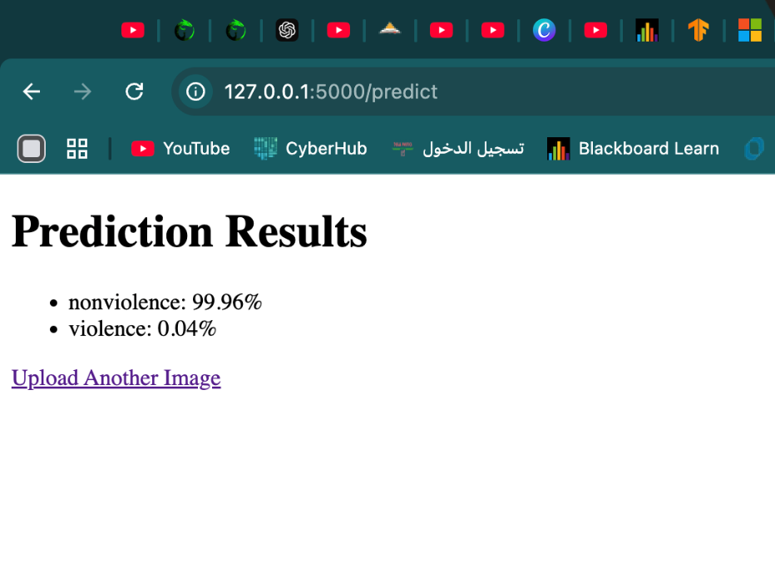

figure37

4.4 Summary -----------------------------------------------------------------------------------4

In conclusion we gathered videos to our video classification model and manually extracted frames to train azure custom vision model. There are two ways to test the models one by using website interface and the other is by azure custom vision model and directly using the predict_video_class(video_path) function.

Chapter Five:

1. **Data Analysis**

The dataset used in this project consists of two categories of videos: violence and non-violence. A key observation was that violence videos are typically shorter, lasting between 5 and 6 seconds, while non-violence videos tend to be longer, usually between 7 and 10 seconds. During preprocessing, we consistently extracted 10 frames from each video, ensuring a standardized input for the model. This step helped mitigate any variations in video length, allowing for a consistent format for training.



figure38

**2. Model Architecture:** The model for this project integrated multiple methods to classify videos into either violence or non-violence. The key layers included:

* **Conv3D Layers:** These were used to identify spatial and temporal features from the video frames. The kernel size was set to (3, 3, 3), with an input shape of (10, 64, 64, 3), representing 10 frames of 64×64 resolution with 3 color channels.
* **LSTM Layer:** This layer captured the sequential nature of the frames, allowing the model to learn how actions evolve over time.
* **Dense Layers and Dropout:** These were included to enhance the model's performance and reduce overfitting.

To prepare the dataset, frames were resized to 64×64 pixels, and pixel values were normalized to a range of 0 to 1. The model was trained for 15 epochs with a batch size of 8, using binary cross-entropy as the loss function and accuracy as the evaluation metric. This combination of spatial and temporal modeling led to strong performance on the training data.

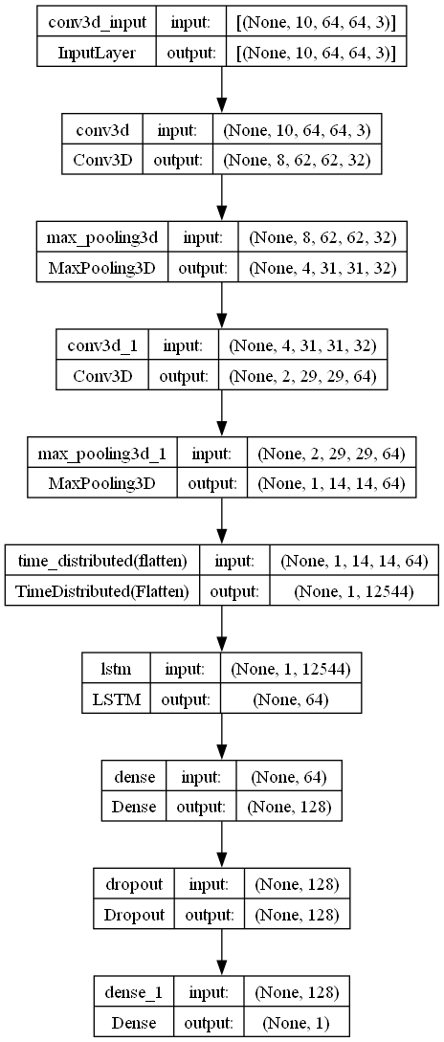

figure39

**3.Data Preprocessing:**

For preprocessing, we extracted 10 frames from each video, ensuring that videos of different lengths were represented consistently. The frames were resized to 64×64 pixels and normalized so the model could learn from a uniform set of inputs. This preprocessing step accounted for the length disparity between violence and non-violence videos, ensuring that frame extraction occurred at regular intervals to avoid biasing the model.

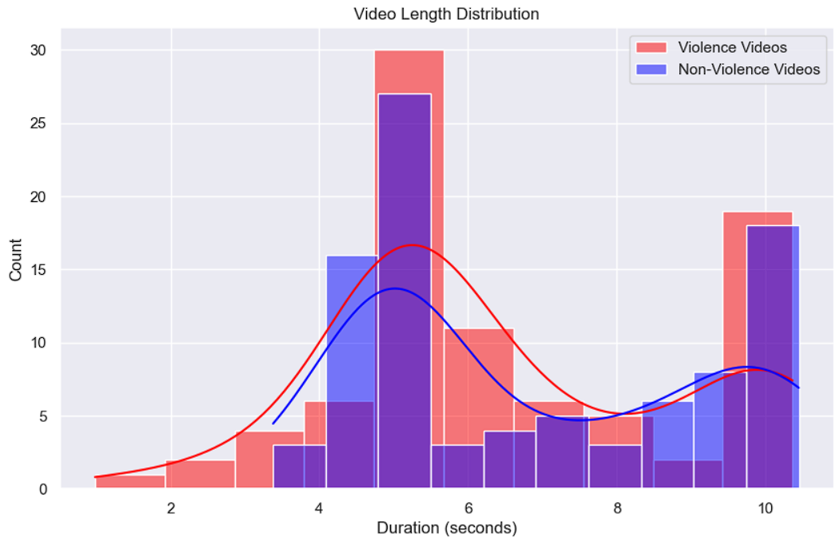

figure40

We also found that the frames extracted from non-violence data were more than the frames extracted from violence data by a small different, that must not affect the performance of the model .

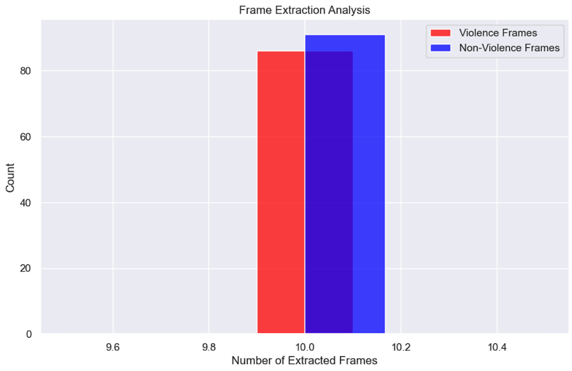

figure41

**4.Model Evaluation:**

The performance of the model was assessed using several metrics. The evaluate() function provided the overall accuracy and loss FIGURE 32:



figure42

values for the test data. We also tracked the accuracy and loss during training to understand how the model improved over time.

FIGURE 33:

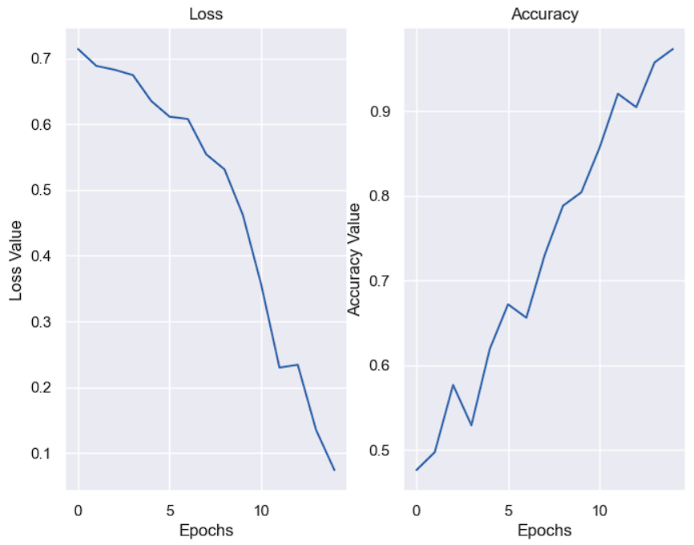

figure44

To further analyze performance, we generated a **confusion matrix** to compare the number of correct and incorrect predictions for both categories.

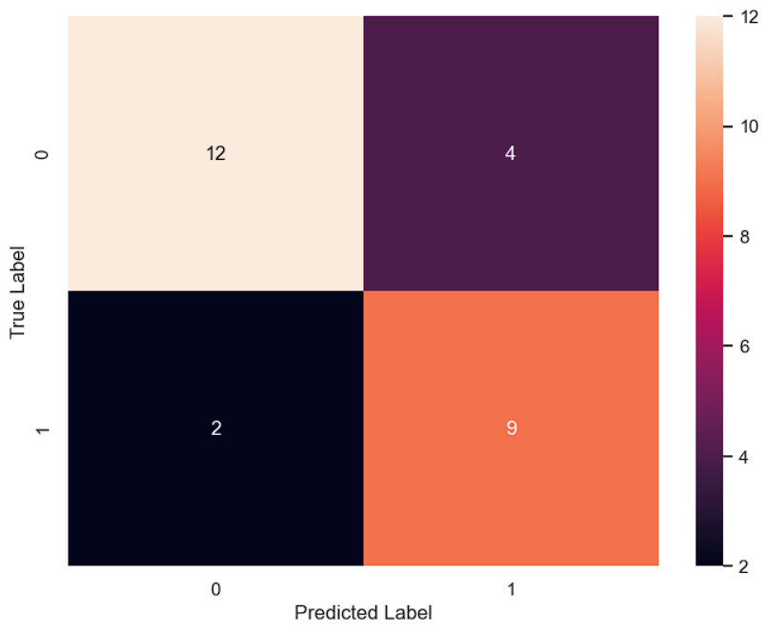

figure44

Additionally, a **classification report** was produced, providing metrics like precision, recall, and F1-score for each class.

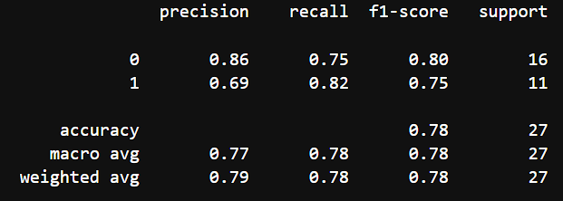

figure45

These metrics helped gauge how well the model distinguished between violence and non-violence.

**5. Key Findings:**

* **Video Analysis:**
  + Violence videos were mostly between 5–6 seconds long, while non-violence videos ranged from 7 to 10 seconds.
  + Preprocessing involved extracting 10 frames per video at regular intervals to ensure fair representation, despite differences in video length.
* **Model Performance:**
  + The model achieved an accuracy of **0.77**, meaning it correctly classified 77% of test videos.
  + The loss was **0.83**, indicating there is room for improvement.
  + According to the confusion matrix, the model correctly classified **21 videos** and made **6 incorrect predictions**.
* **Classification Report:**
  + **Precision** (the proportion of positive predictions that were correct):
    - Non-violence (Class 0): 0.86
    - Violence (Class 1): 0.69
  + **Recall** (the proportion of actual positives correctly identified):
    - Non-violence (Class 0): 0.75
    - Violence (Class 1): 0.82
  + **F1-Score** (the balance between precision and recall):
    - Non-violence (Class 0): 0.80
    - Violence (Class 1): 0.75

**6. Challenges and Future Improvements:**

Several challenges were encountered during the study:

* **Video Preprocessing Issues:** Some videos could not be processed due to issues like corruption or missing frames.
* **Unbalanced Dataset:** The dataset contained unequal amounts of violence and non-violence videos, which may have impacted performance.

To address these issues, future work could involve:

* Expanding the dataset by adding more diverse and high-quality videos.
* Experimenting with advanced model architectures to improve accuracy and robustness.

**7. Discussion Related to Study Objectives:**

The primary objective of this study was to create a model capable of classifying videos as either violence or non-violence. The results suggest the model achieved this goal with an accuracy of 77%. Notably, the model performed better at classifying non-violence videos (with higher precision) and showed strong recall for violence videos. This indicates that the model was more reliable in detecting non-violence content but also had a good ability to identify violence when it appeared.

The study also identified a few challenges, such as issues with video preprocessing and the unbalanced dataset, which highlight the importance of improving data quality and diversity in future research.

**8. Discussion on the Proposed Model:**

The proposed model used a combination of Conv3D layers and LSTM layers to learn both spatial and temporal features from the videos. The architecture performed well, achieving a 77% accuracy. While the model showed promising results, the challenges with unbalanced data and video preprocessing suggest areas for improvement.

The hypothesis that the model could learn patterns from short video clips was confirmed. However, refining the dataset and experimenting with more sophisticated architectures could lead to improved performance in future iterations.

**Summary:**

This study aimed to build a video classification model to differentiate between violence and non-violence content. The analysis revealed that violence videos were typically shorter than non-violence videos. The model achieved an accuracy of 77%, with solid performance in precision, recall, and F1-score for non-violence videos and slightly lower performance for violence videos. While the model showed promising results, challenges like unbalanced data and preprocessing issues were noted. Future improvements could include enhancing the dataset and exploring alternative architectures to improve the model's performance and generalization.

Chapter Six:

Conclusions AND FUTURE WORK

6.1 Conclusion 6

In conclusion we devolved an AI video classification model that classifies short videos (5s-20s) videos into two categories ( violence , non-violence ) using Convolutional Neural Network (CNNs) Algorithm conv3D which is used to and Long Short-term Memory (LSTM)

6.2 Contributions and implications of the study--------------------------------------6

This project contribute to the safety of children and to create a safe community environment for young kids and to protect them from the danger of TV coming from someone who is deeply traumatized from watching Sally’s Cartoon show (كرتون سالي) as a kid. To the point my family deleted spacetoon channel from the whole TV

6.3 Limitations of the study-------------------------------------------------------------6

This project was trained only on detection violent frames meaning if a video contain violent audio content it well not be detected using our model. Also,

This tool is not integrated yet to be used against harmful content and in real life violence in cartoon is not the only danger. Kids now are exposed to many threats such as video games and social media..etc. also this project is designed for short videos and uses a fixed number of frames

6.2 Future Work 6

We will be integrating this model as a tool that can be used by parent’s to protect their kids against violent content whether it was from cartoons or the internet. Also expend the Dataset and train the model to detect various types of violence forms such as in Audio , Text..ect. to detect violence in it’s many forms

Appendix

B: Programming codes 7

Azure :

from flask import Flask, request, render_template

import requests

app = Flask(__name__)

# Azure Custom Vision details

API_URL = "https://vdetect-prediction.cognitiveservices.azure.com/customvision/v3.0/Prediction/8c6feaac-2413-4dd9-8897-2df84d50e3aa/classify/iterations/Iteration7/image"

PREDICTION_KEY = "9a12e271e36a4ffc92da1e9d95d56c15"

@app.route("/")

def index():

return render_template("index.html")

@app.route("/predict", methods=["POST"])

def predict():

image = request.files["image"]

headers = {

"Prediction-Key": PREDICTION_KEY,

"Content-Type": "application/octet-stream",

}

try:

response = requests.post(API_URL, headers=headers, data=image.read())

if response.status_code == 200:

predictions = response.json()["predictions"]

results = [(p["tagName"], round(p["probability"] * 100, 2)) for p in predictions]

return render_template("result.html", predictions=results)

else:

return f"Error: {response.status_code} - {response.text}", 500

except Exception as e:

return f"An error occurred: {str(e)}", 500

if __name__ == "__main__":

app.run(debug=True)

Video classfication AI model:

import os as os

import cv2

import numpy as np

import tensorflow as tf

from tensorflow.keras.models import Sequential

from tensorflow.keras.layers import Conv3D, MaxPooling3D, Flatten, Dense, Dropout, LSTM, TimeDistributed, Reshape

from flask import Flask, render_template, request, redirect, url_for, jsonify

import matplotlib.pyplot as plt

import seaborn as sns

import warnings

sns.set(context='notebook', style='darkgrid', palette='deep', font='sans-serif', font_scale=1, color_codes=False, rc=None)

warnings.filterwarnings("always")

warnings.filterwarnings("ignore")

#constant virable

IMG_SIZE = 64

NUM_FRAMES = 10

LABELS = {0: 'non-violence', 1: 'violence'}

def preprocess_video(video_path, num_frames=NUM_FRAMES):

cap = cv2.VideoCapture(video_path)

frames = []

frame_count = int(cap.get(cv2.CAP_PROP_FRAME_COUNT)) # count number of frame in a video

if frame_count == 0:

print("Error: Video is empty or corrupted.")

return None

interval = max(1, frame_count // num_frames)

for i in range(num_frames):

cap.set(cv2.CAP_PROP_POS_FRAMES, i * interval)

ret, frame = cap.read()

if ret:

frame = cv2.resize(frame, (IMG_SIZE, IMG_SIZE))

frame = cv2.cvtColor(frame, cv2.COLOR_BGR2RGB)

frames.append(frame) #frames is list and it add it to the list

cap.release()

if len(frames) != num_frames:

print("Error: Not enough frames extracted. Check video file.")

return None

frames = np.array(frames) / 255.0

return frames.reshape(num_frames, IMG_SIZE, IMG_SIZE, 3)

violence_path = r"/Users/raghadk/Documents/violence Detection/costom-videos-dataset/train/violence"

non_violence_path = r"/Users/raghadk/Documents/violence Detection/costom-videos-dataset/train/non-violence"

plt.figure(figsize=(10, 6))

sns.histplot(violence_durations, color='red', label='Violence Videos', kde=True, bins=12)

sns.histplot(non_violence_durations, color='blue', label='Non-Violence Videos', kde=True, bins=12)

plt.title('Video Length Distribution')

plt.xlabel('Duration (seconds)')

plt.ylabel('Count')

plt.legend()

plt.show()

def analyze_frame_extraction(data_path, num_frames=NUM_FRAMES):

extracted_frames_counts = []

for video_name in os.listdir(data_path):

video_path = os.path.join(data_path, video_name)

frames = preprocess_video(video_path, num_frames=num_frames)

if frames is not None:

extracted_frames_counts.append(frames.shape[0])

return extracted_frames_counts

violence_frames = analyze_frame_extraction(violence_path)

non_violence_frames = analyze_frame_extraction(non_violence_path)

plt.figure(figsize=(10, 6))

sns.histplot(violence_frames, color='red', label='Violence Frames', kde=False, bins=5)

sns.histplot(non_violence_frames, color='blue', label='Non-Violence Frames', kde=False, bins=6)

plt.title('Frame Extraction Analysis')

plt.xlabel('Number of Extracted Frames')

plt.ylabel('Count')

plt.legend()

plt.show()

def load_data(data_path, label):

data = []

labels = []

for video_name in os.listdir(data_path):

video_path = os.path.join(data_path, video_name)

frames = preprocess_video(video_path)

if frames is not None:

data.append(frames)

labels.append(label)

return np.array(data), np.array(labels)

train_violence_data, train_violence_labels = load_data(r"/Users/raghadk/Documents/violence Detection/costom-videos-dataset/train/violence", label=1)

train_non_violence_data, train_non_violence_labels = load_data(r"/Users/raghadk/Documents/violence Detection/costom-videos-dataset/train/non-violence", label=0)

test_violence_data, test_violence_labels = load_data(r"/Users/raghadk/Documents/violence Detection/costom-videos-dataset/test/violence", label=1)

test_non_violence_data, test_non_violence_labels = load_data(r"/Users/raghadk/Documents/violence Detection/costom-videos-dataset/test/non-violence", label=0)

X_train = np.concatenate((train_violence_data, train_non_violence_data), axis=0)

y_train = np.concatenate((train_violence_labels, train_non_violence_labels), axis=0)

X_test = np.concatenate((test_violence_data, test_non_violence_data), axis=0)

y_test = np.concatenate((test_violence_labels, test_non_violence_labels), axis=0)

X_train = X_train.reshape(-1, NUM_FRAMES, IMG_SIZE, IMG_SIZE, 3)

model = Sequential([

Conv3D(32, (3, 3, 3), activation='relu', input_shape=(NUM_FRAMES, IMG_SIZE, IMG_SIZE, 3)),

MaxPooling3D((2, 2, 2)),

Conv3D(64, (3, 3, 3), activation='relu'),

MaxPooling3D((2, 2, 2)),

TimeDistributed(Flatten()),

LSTM(64, return_sequences=False),

Dense(128, activation='relu'),

Dropout(0.5),

Dense(1, activation='sigmoid')

])

model.compile(optimizer='adam', loss='binary_crossentropy', metrics=['accuracy'])

model.fit(X_train,

y_train,

epochs=20,

batch_size=8,

verbose=1)

model.save("violence_detection_model.h5")

from tensorflow.keras.models import load_model

model = load_model("violence_detection_model.h5")

model.evaluate(X_test, y_test)

def predict_video_for_evaluation(video_path):

processed_video = video_path.reshape(1, NUM_FRAMES, IMG_SIZE, IMG_SIZE, 3)

prediction = model.predict(processed_video)

predicted_label = 1 if (prediction[0] > 0.5) else 0

return predicted_label

predictions = [predict_video_for_evaluation(video) for video in X_test]

from sklearn.metrics import confusion_matrix, classification_report

cm = confusion_matrix(y_test, predictions)

sns.heatmap(cm, annot=True)

plt.xlabel('Predicted Label')

plt.ylabel('True Label')

plt.show()

def predict_video_class(video_path):

processed_video = preprocess_video(video_path)

if processed_video is None:

print("Error: Video preprocessing failed.")

return None

processed_video = processed_video.reshape(1, NUM_FRAMES, IMG_SIZE, IMG_SIZE, 3)

prediction = model.predict(processed_video)

print("Prediction: ", prediction)

predicted_label = LABELS[int(prediction[0] > 0.5)]

print("Predicted Class: ", predicted_label)

return predicted_label

video_path = r"/Users/raghadk/Documents/violence Detection/costom-videos-dataset/test/violence/VIDEO-2024-09-22-16-06-01.mp4"

predicted_label = predict_video_class(video_path)

if predicted_label:

print("The video is classified as: ", predicted_label)

app = Flask(__name__)

app.config['UPLOAD_FOLDER'] = 'uploads'

os.makedirs(app.config['UPLOAD_FOLDER'], exist_ok=True)

@app.route('/')

def index():

return render_template('index.html')

@app.route('/upload', methods=['POST'])

def upload_video():

try:

if 'input_video' not in request.files:

print("No file part in the request")

return jsonify({"error": "No file part in the request"})

file = request.files['input_video']

if file.filename == '':

print("No file selected")

return jsonify({"error": "No file selected"})

if not file.filename.endswith(('mp4', 'mov')):

print("Invalid file format")

return jsonify({"error": "Invalid file format"})

filepath = os.path.join(app.config['UPLOAD_FOLDER'], file.filename)

file.save(filepath)

print("File saved at: ", filepath)

processed_video = preprocess_video(filepath)

if processed_video is None:

print("Video preprocessing failed")

return jsonify({"error": "Error processing video"})

processed_video = processed_video.reshape(1, NUM_FRAMES, IMG_SIZE, IMG_SIZE, 3)

prediction = model.predict(processed_video)

print("Prediction: ", prediction)

result = LABELS[int(prediction[0][0] > 0.5)]

print("Prediction result: ", result)

return jsonify({"result": result})

except Exception as e:

print("Exception occurred: ", str(e))

return jsonify({"error": "An internal error occurred"})

app.run(debug=False)

References 8

<https://learn.microsoft.com/en-us/azure/ai-services/custom-vision-service/use-prediction-api>

<https://sfoteini.github.io/blog/build-a-flower-classification-model-with-azure-custom-vision/>

<https://learn.microsoft.com/en-us/azure/ai-services/custom-vision-service/>

<https://docs.python.org/3/tutorial/controlflow.html>

<https://docs.opencv.org/4.5.4/d6/d00/tutorial_py_root.html>

<https://medium.com/@patelharsh7458/normalization-in-image-preprocessing-scaling-pixel-values-by-1-255-111b2fa496d4#:~:text=Dividing%20each%20pixel%20value%20by,255%20%3D%200.50196%20after%20the%20scaling>.

<https://www.tensorflow.org/tutorials/video/video_classification>

**List of Figures**

Figure 1: Title of the figure 9

Figure 2: Title of the figure 10

Figure 3: Title of the figure 17

Figure 4: Title of the figure 17

Figure 5: Title of the figure 18

Figure 6: Title of the figure 18

Figure 7: Title of the figure 20

Figure 8: Title of the figure 20

Figure 9: Title of the figure 21

Figure 10: Title of the figure 21

Figure 11: Title of the figure 22

Figure 12: Title of the figure 1

Figure 13: Title of the figure 1

Figure 14: Title of the figure 1

Figure 15: Title of the figure 1

Figure 16: Title of the figure 1

Figure 17: Title of the figure 1

Figure 18: Title of the figure 1

Figure 19: Title of the figure 1

Figure 20: Title of the figure 1

Figure 21: Title of the figure 1

Figure 22: Title of the figure 1

Figure 23: Title of the figure 1

Figure 24: Title of the figure 1

Figure 26: Title of the figure 1

Figure 27: Title of the figure 1

Figure 28: Title of the figure 1

Figure 29: Title of the figure 1

Figure 30: Title of the figure 1

Figure 31: Title of the figure 1

Figure 32: Title of the figure 1

Figure 34: Title of the figure 1

Figure 36: Title of the figure 1

Figure 37: Title of the figure 1

Figure 38: Title of the figure 1

Figure 39: Title of the figure 37

Figure 40: Title of the figure 38

Figure 41: Title of the figure 38

Figure 42: Title of the figure 39

Figure 43: Title of the figure 39

Figure 44: Title of the figure 39

Figure 45: Title of the figure 40

List of Abbreviation

All the abbreviation used should be listed alphabetically.

AI: Artificial intelligence

CNNs : is a type of Deep learning neural network  architecture commonly used in Computer Vision. Computer vision is a field of Artificial Intelligence that enables a computer to understand and interpret the image or visual data..

Conv3D: 3D convolution layer this layer creates a convolution kernel that is convolved with the layer input over a 3D spatial (or temporal) dimension (width,height and depth) to produce a tensor of outputs. If use_bias is True, a bias vector is created and added to the output

LSTM: Long Short-Term Memory Networks (LSTM) are a type of advanced recurrent neural network that includes specialized "gates" within its structure to manage long-term and short-term memory, preventing common issues like gradient vanishing or exploding in standard RNNs.

NN: neural network are a subset of machine learning, and they are at the heart of deep learning algorithms. They are comprised of node layers, containing an input layer, one or more hidden layers, and an output layer. Each node connects to another and has an associated weight and threshold. If the output of any individual node is above the specified threshold value, that node is activated, sending data to the next layer of the network. Otherwise, no data is passed along to the next layer of the network.

RNNs : A recurrent neural network or RNN is a deep nueral network trained on sequential or time series data to create a mashine learning (ML) model that can make sequential predictions or conclusions based on sequential inputs.

Appendix

A: Project Installation:

* + 1. Install python

https://youtu.be/yivyNCtVVDk

* + 1. Install anaconda

https://youtu.be/UTqOXwAi1pE

* + 1. Install TensorFlow and keras

https://youtu.be/L4Y7A44lzpM

References

*Tahira Khalila, Javed Iqbal Bangashb, Abdul Waheed Khanc, Saima Anwar Lasharid, Abdullah Khanb, Dzati Athiar Ramlie*"**Detection of Violence in Cartoon Videos Using Visual Features**" (2021)

‍